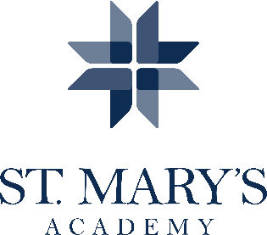
Art Teacher (Full time)

POSTING DATE: February 17, 2017
CLOSING DATE: March 20, 2017
START DATE: August 18 2017

GENERAL SUMMARY: Seeking innovative and collaborative art educator for unique college prep setting. Be community minded, love your work and be inspired by the mission of the Sisters of the Holy Names of Jesus and Mary. Additional duties include teacher advisory/homeroom and in-house substitution. Candidates of color are encouraged and welcome.
A creative, future-focused philosophy for program expansion to serve the needs of students from high school through career is a foundational goal of the St. Mary’s Fine Arts Department; the ideal candidate will be able to contribute dynamic energy to these endeavors. Additionally, the candidate will demonstrate strong interpersonal, communication, and organizational skills; familiarity with the goals of an independent college preparatory school for young women and the ability to respond effectively to the needs of a diverse student and parent population with high expectations for teaching and learning.
The Art teacher is responsible for developing in each student an interest in and the ability for creative expression in visual terms, using skills and techniques of artistic expression consistent with school guidelines. The effective teacher supports students to develop their aesthetic understandings and appreciations as well as discover their unique talents in the field of art. The current visual arts program includes courses in general visual arts, drawing, watercolor, ceramics, photography, graphic design and AP Studio Art. Additional responsibilities may include advising the National Art Honor Society, facilitating submissions to scholastic art competitions and art club.

QUALIFICATIONS: Bachelors or Master’s degree in Secondary Education with a fine arts major or emphasis. Current Oregon TSPC Licensure required with appropriate endorsement required. Experience with the AP Studio Art curriculum highly preferred.
Application Guidelines: Please read the SNJM Statement carefully; download the faculty application form from www.stmaryspdx.org. Complete it and send along with a Letter of Inquiry, resume and professional references to Personnel/Math, St. Mary’s Academy, 1615 SW 5th Ave., Portland, OR 97201 or email materials to personnel@smapdx.org. No phone calls, please.

St. Mary’s Academy is an Equal Opportunity Employer

